Revised operational strategy [Updated 1/12/2026]

V-Dem provides a summary measure of how free and fair elections are, on average, at the subnational level (v2elffelr), which is on the same scale, with the same category definitions, as Elections free and fair at the national level (v2elfrfair). The summary subnational measure is not actually an average of ratings of subnational units, as such ratings do not exist. Rather, it is, in effect, a summary of expert judgments of what such an average would be if such ratings did exist. The national and subnational measures tend to be correlated but are still somewhat independent of each other. (Figure 1 compares them for Colombia since 1900: national in blue, subnational in red.)
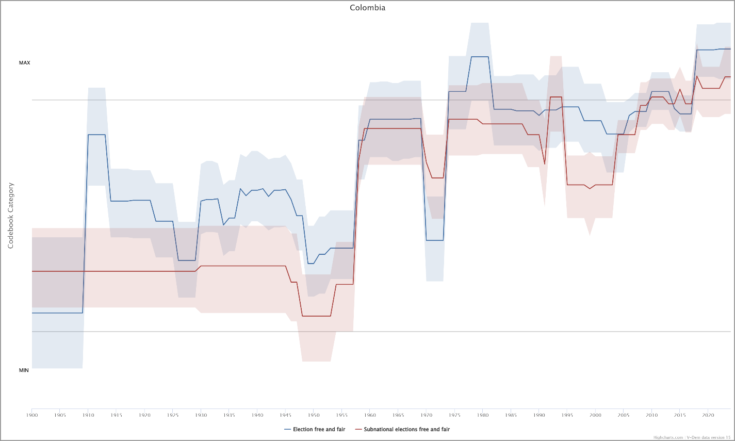

Figure 1: National and subnational electoral unevenness

We conceive of free and fair elections at the municipal level as a set of deviations centered around this summary subnational measure. In order to benchmark the many municipal-level values, we need to determine (a) the maximum range of variation around the summary measure in the entire country in a given year and (b) how high or low each municipality is within that range.

We can produce a reasonable estimate of the maximum national range by combining two other sources of information V-Dem provides: (1) the highest posterior density (HPD) of the summary subnational measure and (2) a measure of Subnational election unevenness. The HPD is a kind of Bayesian confidence interval. It is depicted by the color bands around the lines in Figure 1. Specifically, the upper and lower bounds of the HPD contain 68 percent of the measurement model estimates of this variable for the corresponding country-year. In other words, there is a 68 percent chance that the HPD interval contains the true value of Subnational elections free and fair. V-Dem’s measurement team chose the 68 percent interval to make it somewhat equivalent to the familiar concept of the standard deviation. The HPD therefore provides some approximate guidance about how large differences must be in order to be counted as “significant,” as differences are usually treated as statistically significant when they exceed roughly two standard deviations. We can calculate the plus-or-minus-one-HPD range by subtracting v2elsnlsff_codelow from v2elsnlsff_codehigh (two variables included in the aggregate V-Dem data set that report the bounds of this range).

The other source of information on the range, unevenness, captures expert responses to this question (v2elsnlsff):

Does the freeness and fairness of subnational elections vary across different areas of the country?
Clarification: Subnational elections refer to elections to regional or local offices, as specified above.

Responses:
0: Yes. Subnational elections in some areas of the country are significantly more free and fair (or, alternatively, significantly less free and fair) than subnational elections in other areas of the country.
1: Somewhat. Subnational elections in some areas of the country are somewhat more free and fair (or, alternatively, somewhat less free and fair) than subnational elections in other areas of the country.
2: No. Subnational elections in most or all areas of the country are equally free and fair (or, alternatively, equally not free and not fair).

Country experts have answered this question for each country-year. If all the experts chose answer 2, we would multiply the HPD by 2 - v2elsnlsff = 0 to reflect the belief that the quality of elections does not vary at all at the subnational level. If the all the experts chose answer 0, we would multiply the HPD by 2 - v2elsnlsff = 2 to implement the expert guidance that the range of variation is around two standard deviations and therefore, in a sense, significant. If all the experts chose answer 1, the multiplier would be 2 - v2elsnlsff = 1, reflecting the expert judgment that values vary “somewhat” but not “significantly,” which corresponds to variation of less than two standard deviations. To be sure, the country experts do not necessarily agree on whether subnational units vary significantly, only somewhat, or not at all, so the actual range in practice will be a weighted average between zero and two HPDs. The range of variation in the freeness and fairness of subnational elections, Range, is therefore measured as

$${Range}_{it}= \sum_{1}^{c}{\frac{{HPD}_{it}*[\left(2-{v2elsnlsff_1}_{itc}\right)+2*\left(2-{v2elsnlsff_0}_{itc}\right)]}{v2elsnlsf{f_0}_{itc}+v2elsnlsf{f_1}_{itc}+v2elsnlsf{f_2}_{itc}}}$$
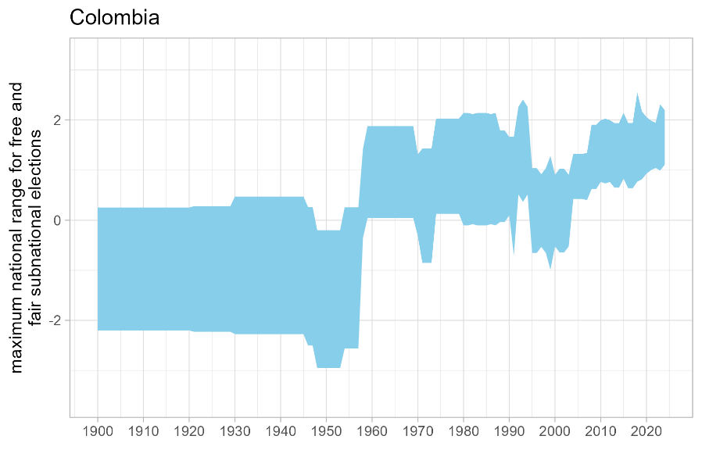
[Note that at the coder level (with subscripts “itc,” the coder scores are ones and zeroes, so the summation of these scores is the number of coders choosing each option (0, 1, or 2) of the unevenness variable.]

The range around the subnational mean is (v2elffelr_{it} + Range_{it}, v2elffelr_{it} – Range_{it}). The result for Colombia is shown in Figure 2.

Figure 2: Subnational electoral mean and range for Colombia

We calculate the range similarly for subnational civil liberties, using the measure of unevenness in the protection of civil liberties at the subnational level (v2clrgunev, with its factor levels v2clrgunev_0, v2clrgunev_1, and v2clrgunev_2) and its corresponding HPD:

$${Range}_{it}= \sum_{1}^{c}{\frac{{HPD}_{it}*[\left(2-{v2clrgunev_1}_{itc}\right)+2*\left(2-{v2clrgunev_2}_{itc}\right)]}{{v2clrgunev_0}_{itc}+{v2clrgunev_1}_{itc}+{v2clrgunev_2}_{itc}}}$$

This range is added to a measure of the national average protection for civil liberties at the subnational level. Because V-Dem lacks a variable to measure exactly this concept, we substitute a proxy. V-Dem does provide an estimate of the percentage of the subnational population that enjoys less protection of civil liberties than the national population (v2clsnlpct). The national-level index of civil liberties is v2x_civlib. We can therefore subtract the product of v2x_civlib by one minus the weaker percentage (divided by 100, to be a proportion) from the national civil liberties index to obtain an estimate of the subnational average. Thus, we estimate the maximum range around the subnational average for civil liberties as
[v2x_civlib_{it} * (1-v2clsnlpct_{it}/100) + Range_{it}, v2x_civlib_{it} * (1-v2clsnlpct_{it}/100) – Range_{it}].

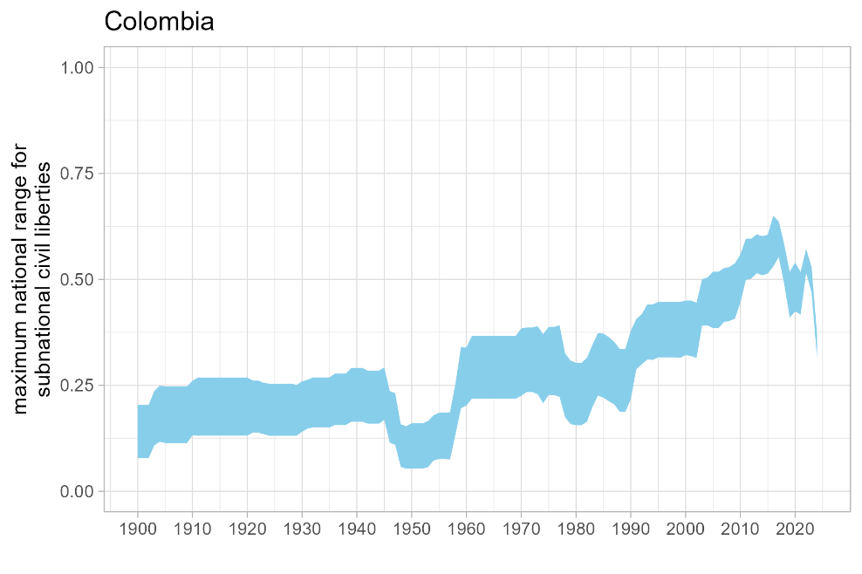
Figure 3 displays the result of this operation.

Figure 3

For both civil liberties and free and fair elections, the characteristics of each location determine how much it varies within that maximum national range. To complete the calibration of the data for cross-national comparisons, the subnational estimates such as those we have generated for Colombia can be centered around the means of their respective series and rescaled to fit within their ranges. The rescaled subnational values are the national mean plus the deviations of the local value from the local mean times the ratio of the national range to the local range:
$$Rescaled {Index}_{m,t}= {Index}_{c,t}+({Index}_{m,t}-{mean Index}_{m,t})*\frac{{Range}_{c,t}}{{central 95\% range of Index}_{m,t}}$$
where “Index” refers to either a measure of free and fair elections or a measure of civil liberties, m indexes municipalities, c denotes the national mean estimate of a subnational index, t indexes years, and Range is as defined above. The central 95% range of an index is the 97.5th percentile of the index minus its 2.5th percentile: bounds that correspond approximately to two standard deviations above and below the mean.
The result of applying this transformation to the Colombian estimates for 2000-2023 is shown in Figures 4 and 5.

[Don’t use the figure below in the January 2026 paper.]
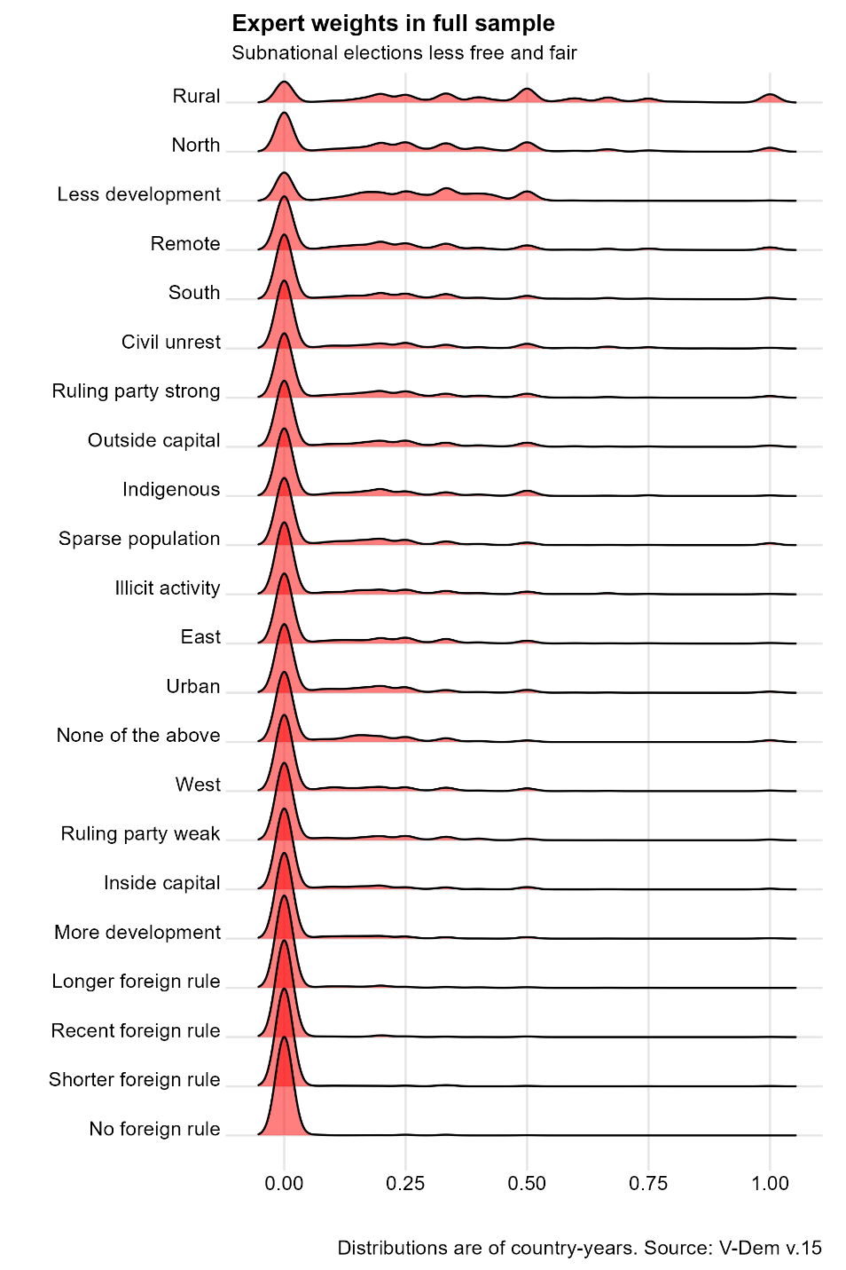
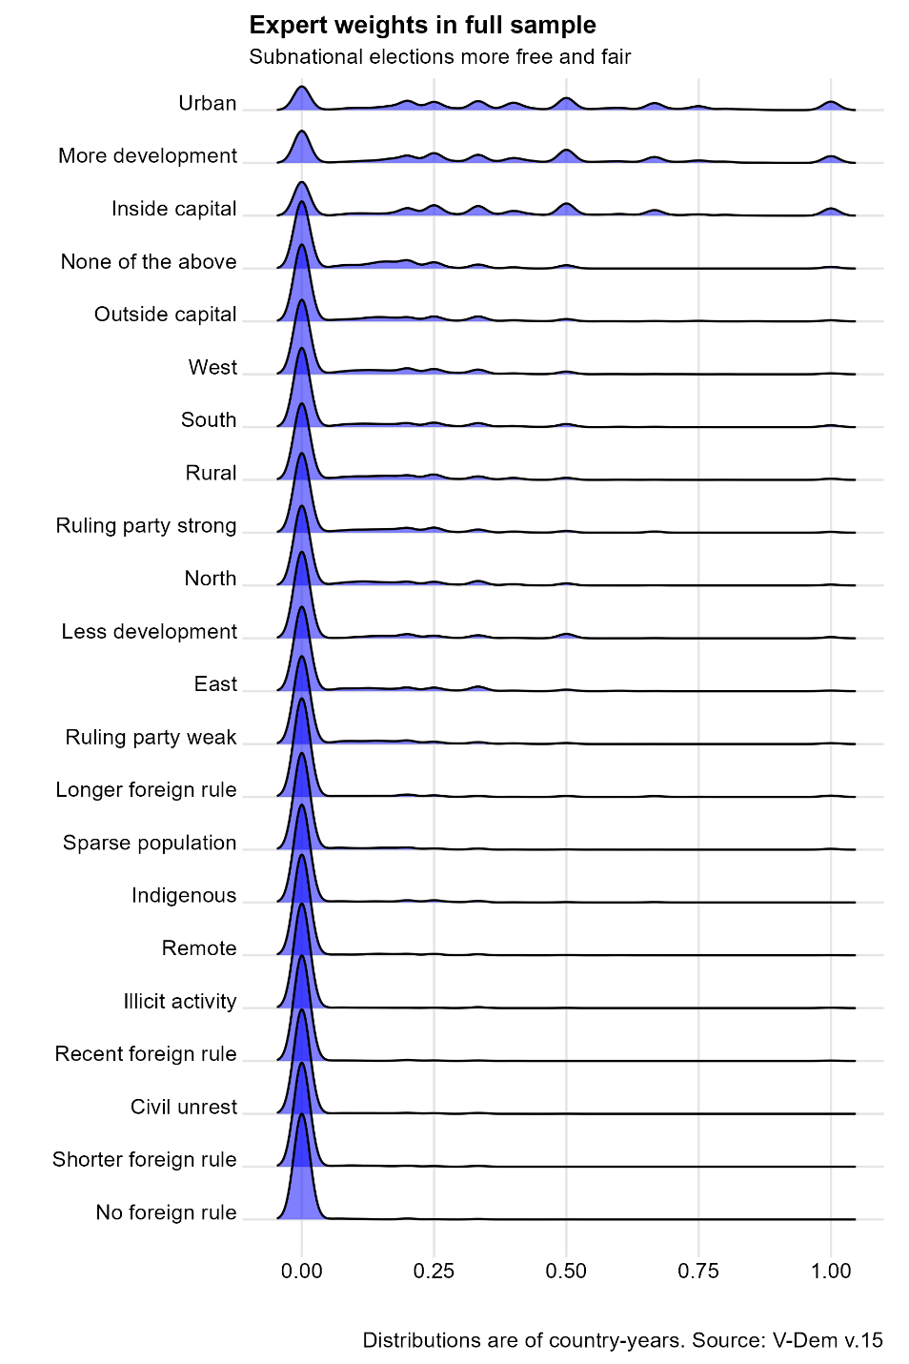

[Rough notes for later sections]

Index definitions
i = country
j = subnational unit
t = time (year)
w = which variable (elections or civil liberties)
k = criterion for relevance
R = summary degree of relevance
r = binary relevance score from each coder
c = coder

Relevance = sum(Range_{itwc} * r_{itwc} )

Consider incorporating into the overall subnational democracy measure:
- Regional government index, local government index, or Division of powers index, all of which measure the degree to which subnational officials are elected and able to govern without interference from unelected authorities. This could be a proxy for the Elected officials index.

Experts who chose 2 on this question were not asked the follow-up questions about the characteristics of regions where elections were more or less free and fair, which we use to weight the predictors of subnational elections. However, we included the number of experts who were filtered out in this way in the denominator when calculating the proportion of experts who chose each weighting criterion.

